THE INSTITUTE OF GREEK & LATIN SUDIES IN FACULTY OF ARTS AT CHARLES UNIVERITY, PRAGUE

PRESENTS

PROFESSOR THANOS VEREMIS (D. Phil, Oxon)
UNIVERSITY OF ATHENS

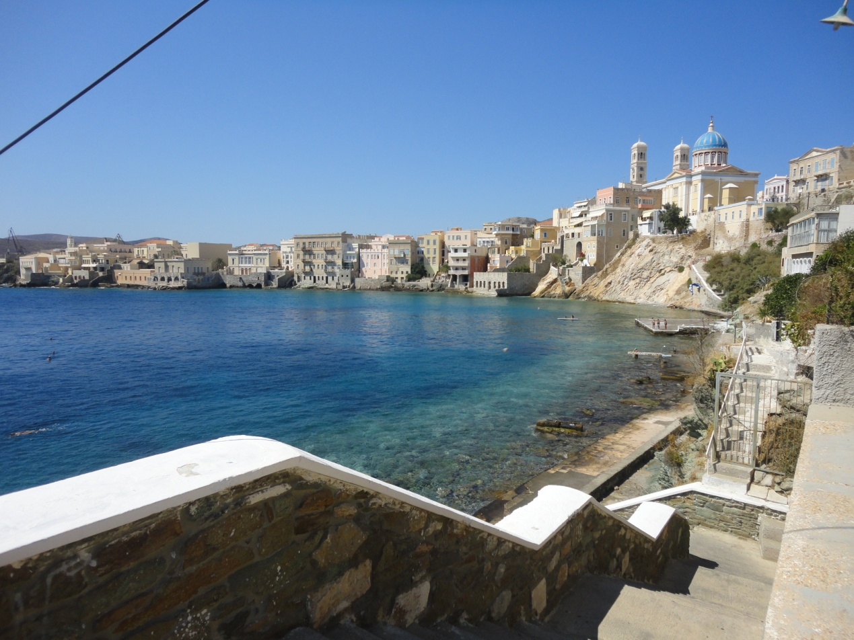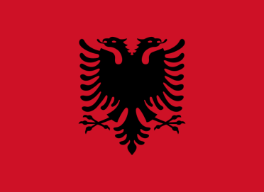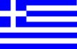

THE MODERN GREEK STATE AND ITS RELATIONS
WITH NEIGHBOURING COUNTRIES

MONDAY, NOVEMBER 14, 2011 at 4:00 pm,
GREEN ROOM, 20 CELETNA Street, PRAGUE 1

